**Constants and Macros Assignment**

1. Write a function macro to find the smallest number in an array of integers.



1. What are the differences between macros and constant. Can you replace a constant with a macro and vice versa? Give examples for your statements

A) **Macros:**

* Macros are preprocessor directives, expanded by the preprocessor before compilation.
* They are typically used to define simple constants or functions.
* Macros are not type-safe and can cause issues if not used carefully, such as operator precedence problems.

**Constants:**

* Constants are fixed values defined by the const keyword and are type-safe.
* Constants are evaluated during runtime, and their value cannot be changed once assigned.

**Can you replace a constant with a macro and vice versa?**

* You can replace constants with macros for simple values. However, replacing complex constants (like float values or array sizes) with macros may lead to unintended behavior.
* Replacing macros with constants may be possible, but macros can handle complex expressions, whereas constants are limited to fixed values.

**Example:**

// Constant Example

const int x = 10; // Type-safe, can be used in any expression.

// Macro Example

#define X 10 // This is just a substitution; no type check.

3. Refer macro below

#define MYPROD(x) (x *x)

WAP to invoke the above macro with inputs as below and display the result.

a. MYPROD(2+1)

b. MYPROD(6+1)

Do you get the expected answers as 9 and 49 in case a. and case b.?

If not modify the code to produce the expected results. in above case

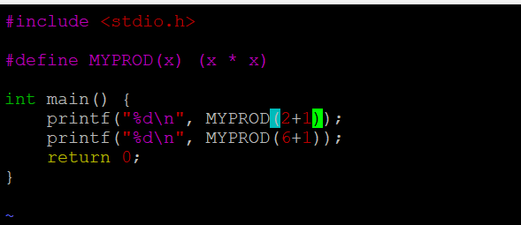

4. Write macro definitions with arguments for calculation of area of a triangle and circle.

a. Use macros for both constants as well as formula evaluations.

b. Store these macro definitions in a header file and invoke the macros from the main function.

5. Define a macro name MYPRINT as below.

#define MYPRINT(x) printf(x)

Use the above macro conditionally only if a macro CUST_PRINT is defined , otherwise not to be used.

For eg refer the code and comments below.

int main()

{

MYPRINT("Hello World"); // will be displayed only when CUST_PRINT is defined

printf("Test"); // will be displayed always irrepective of CUST_PRINT

return 0;

}

Add the code to demonstrate the above behaviour.

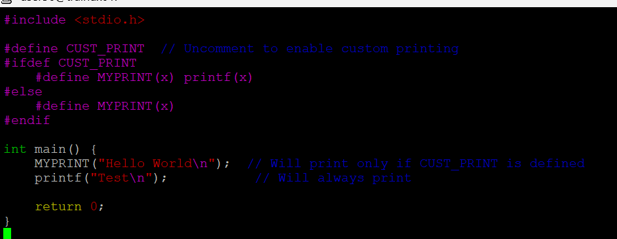

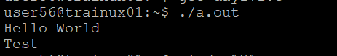

6. Identify and use the macros to display

a. file name

b. function name

c. line of code

Show the usage with a code example



